Using Lego Spike Prime Sets to Teach Essential Coding Concepts Coding Guide

Workshop Step 1:

This is the primary event block. All the code blocks below it will run as soon as you press start button on the Lego Spike program.

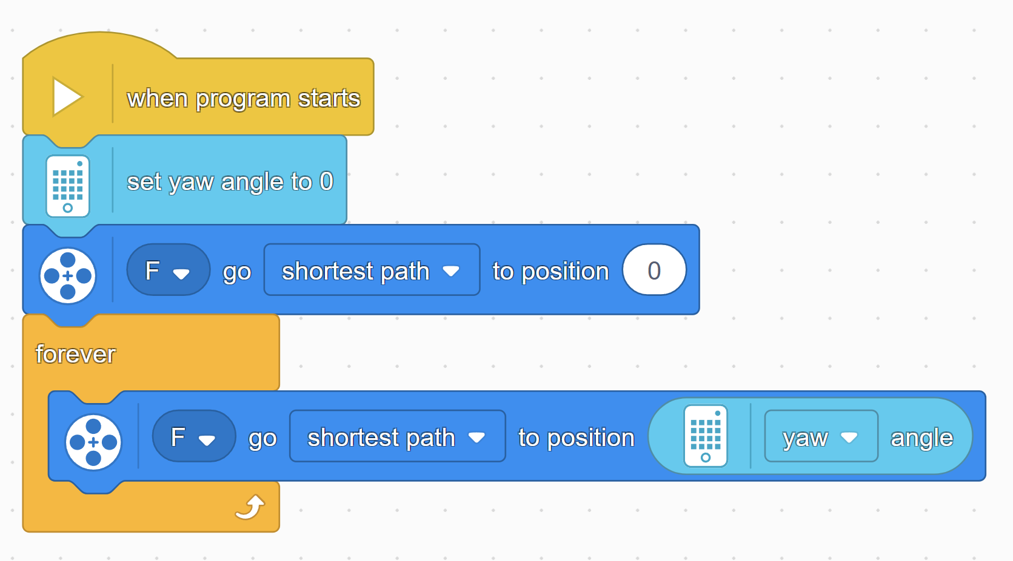

Resets the angle of the gyroscope on the central unit. This is necessary for consistent movement every time you run the program.

Obtains the angle of the gyroscope, allowing you to match the angle of the motor with it.

Motion block that resets the main motor responsible for aiming the catapult. Sets the angle to 0, which aims the catapults straight forward when you first start the program.

Motion block that will continuously aims the catapult.

Forever loop that continuously the action inside. In this case it allows angle of the catapult to always match the angle of the gyroscope.

Workshop Step 2:

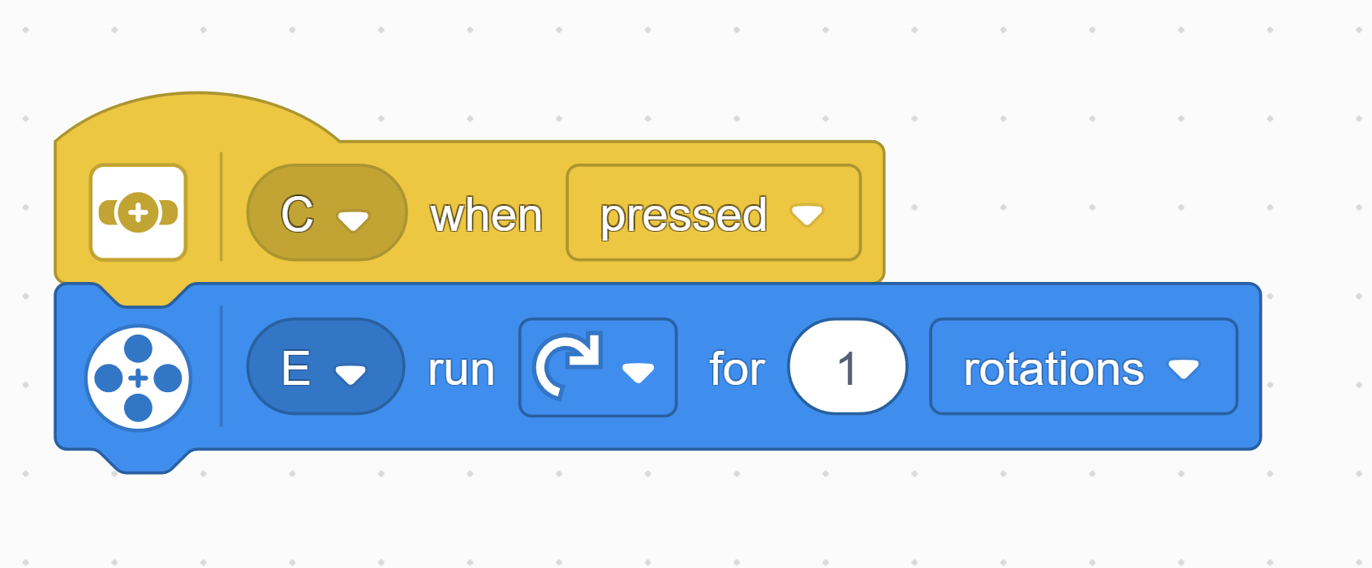

Motion block that rotates the motor responsible for shooting. This rotates the motor one full rotation, or 360°.

Event block tied to the pressure sensor. It recognizes when the sensor is pressed.

Workshop Step 3:

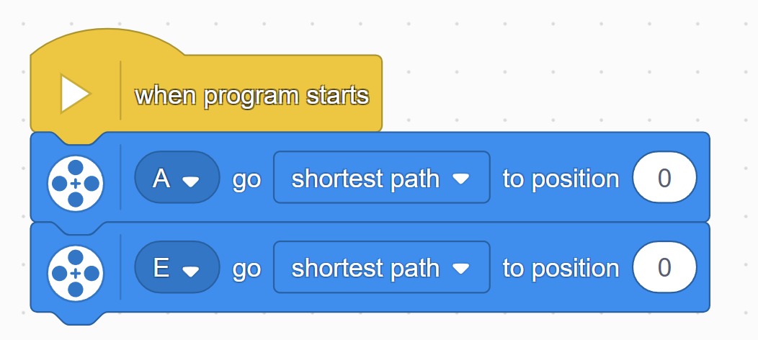

Motion blocks to reset the angle of the aiming and shooting motors.

Main event block.

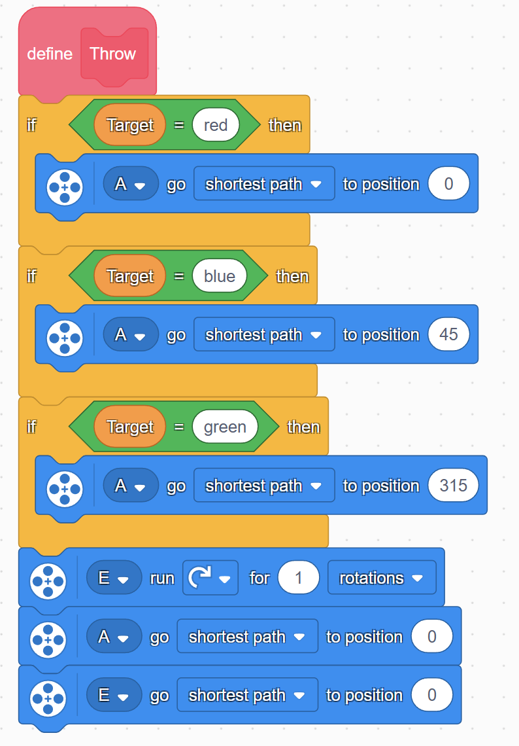

Motion blocks to reset the angle of the aiming and shooting motors.

Motion blocks that control the aiming of the catapult. Each one needs to be set to an angle that reaches the corresponding target.

“Target” is a custom variable that stores the current color of the target.

If statement block that determines the current target. Inside there is a “=” operator block to construct the conditional statement.

Motion block to rotate the shooting motor one complete rotation.

Custom function block that defines the shooting action.

The sensor can be programmed to detect multiple colors, just make sure these colors have a corresponding if statement inside the “Throw” function.

Calls the custom “Throw” function from earlier.

Sets the custom variable “Target” to the name of the detected color.

Event block tied to the color sensor. It performs the actions underneath whenever it recognizes the corresponding color.